1. Create a database named employee, then import **data_science_team.csv** **proj_table.csv** and **emp_record_table.csv** into the **employee**database from the given resources.

1. Create an ER diagram for the given **employee**database.

1. Write a query to fetch EMP_ID, FIRST_NAME, LAST_NAME, GENDER, and DEPARTMENT from the employee record table, and make a list of employees and details of their department.

1. Write a query to fetch EMP_ID, FIRST_NAME, LAST_NAME, GENDER, DEPARTMENT, and EMP_RATING if the EMP_RATING is:

* less than two
* greater than four
* between two and four

1. Write a query to concatenate the FIRST_NAME and the LAST_NAME of employees in the Finance department from the employee table and then give the resultant column alias as NAME.

1. Write a query to list only those employees who have someone reporting to them. Also, show the number of reporters (including the President).
2. Write a query to list down all the employees from the healthcare and finance departments using union. Take data from the employee record table.

1. Write a query to list down employee details such as EMP_ID, FIRST_NAME, LAST_NAME, ROLE, DEPARTMENT, and EMP_RATING grouped by dept. Also include the respective employee rating along with the max emp rating for the department.

1. Write a query to calculate the minimum and the maximum salary of the employees in each role. Take data from the employee record table.

1. Write a query to assign ranks to each employee based on their experience. Take data from the employee record table.

1. Write a query to create a view that displays employees in various countries whose salary is more than six thousand. Take data from the employee record table.

1. Write a nested query to find employees with experience of more than ten years. Take data from the employee record table.

1. Write a query to create a stored procedure to retrieve the details of the employees whose experience is more than three years. Take data from the employee record table.

1. Write a query using stored functions in the project table to check whether the job profile assigned to each employee in the data science team matches the organization’s set standard.

1. Create a database named employee, then import **data_science_team.csv** **proj_table.csv** and **emp_record_table.csv** into the **employee**database from the given resources.

1A. CREATE DATABASE employee;

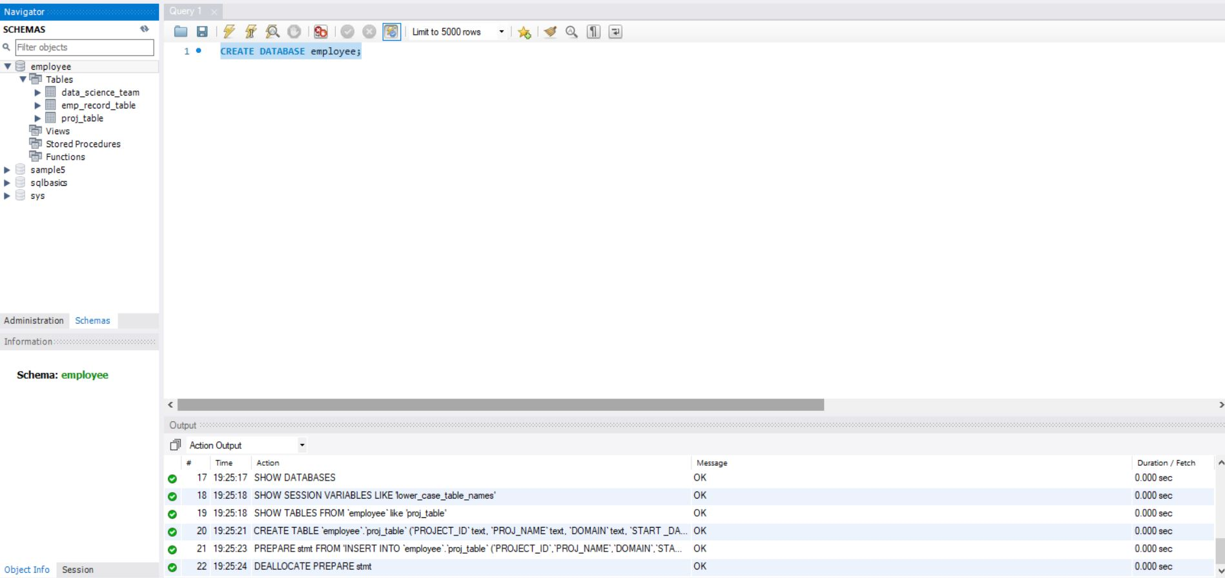

2.Create an ER diagram for the given **employee**database.

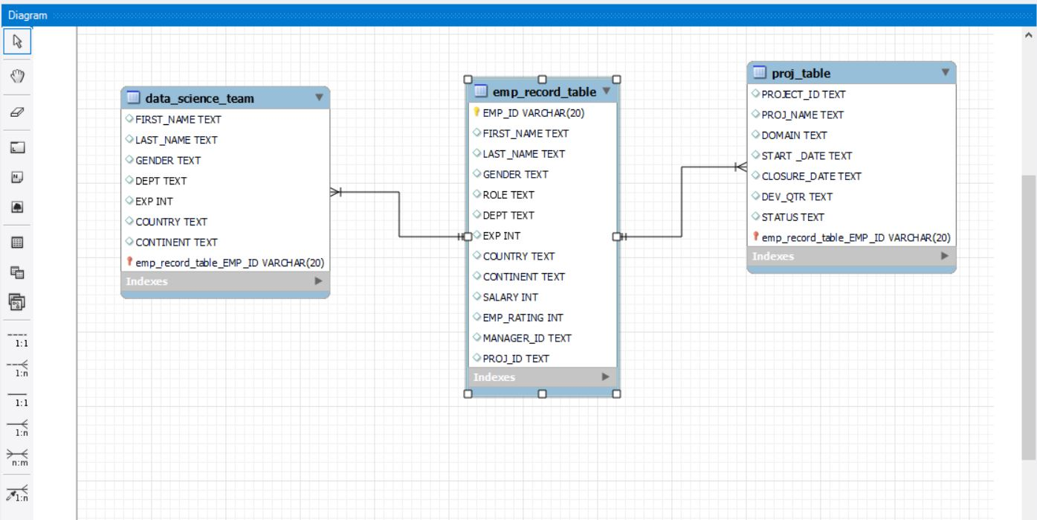

3.Write a query to fetch EMP_ID, FIRST_NAME, LAST_NAME, GENDER, and DEPARTMENT from the employee record table, and make a list of employees and details of their department.

3A.

SELECT EMP_ID, FIRST_NAME, LAST_NAME, GENDER,DEPT

FROM emp_record_table;

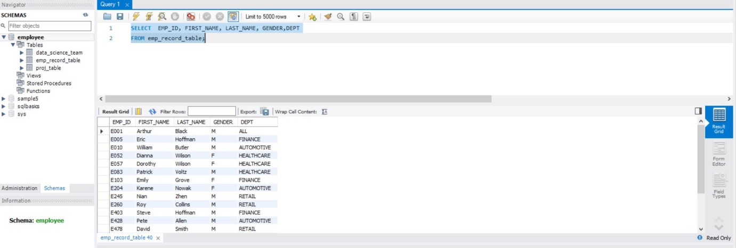

4.Write a query to fetch EMP_ID, FIRST_NAME, LAST_NAME, GENDER, DEPARTMENT, and EMP_RATING if the EMP_RATING is:

* less than two
* greater than four
* between two and four

4A. less than two

SELECT EMP_ID, FIRST_NAME, LAST_NAME, GENDER,DEPT,EMP_RATING FROM emp_record_table

WHERE EMP_RATING<2;

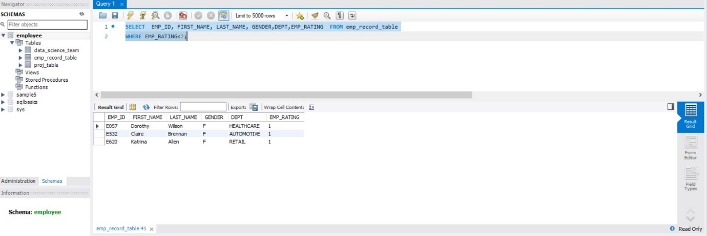

4B.

greater than four

SELECT EMP_ID, FIRST_NAME, LAST_NAME, GENDER,DEPT,EMP_RATING FROM emp_record_table

WHERE EMP_RATING>4;

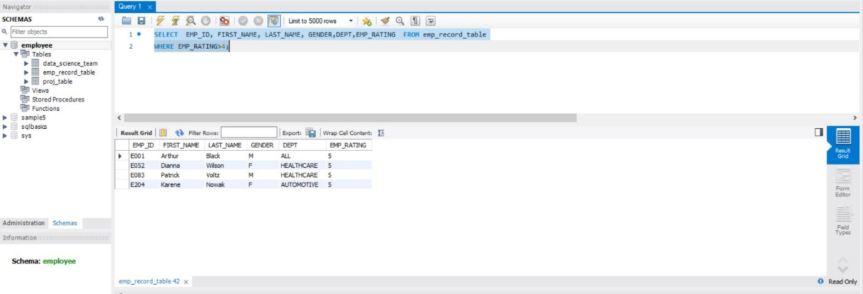

4C.

between two and four

SELECT EMP_ID, FIRST_NAME, LAST_NAME, GENDER,DEPT,EMP_RATING FROM emp_record_table

WHERE EMP_RATING BETWEEN 2 AND 4;

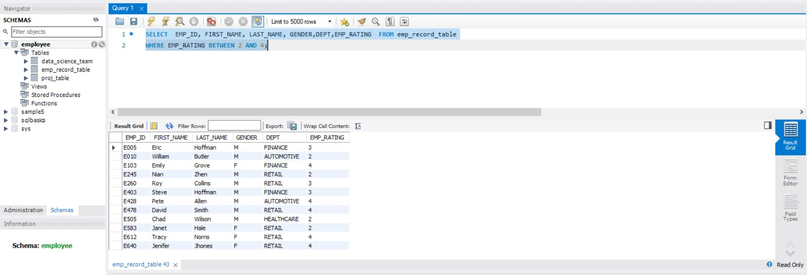

5.Write a query to concatenate the FIRST_NAME and the LAST_NAME of employees in the Finance department from the employee table and then give the resultant column alias as NAME.

SELECT CONCAT(FIRST_NAME,'',LAST_NAME) AS

NAME FROM emp_record_table

WHERE DEPT = "FINANCE";

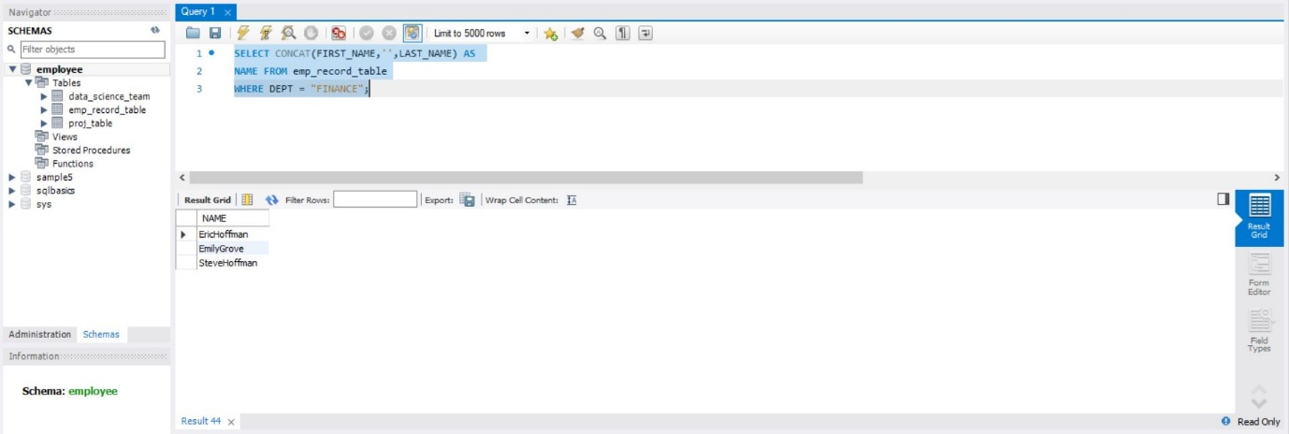

6.Write a query to list only those employees who have someone reporting to them. Also, show the number of reporters (including the President).

SELECT m.EMP_ID,m.FIRST_NAME,m.LAST_NAME,m.ROLE,

m.EXP,COUNT(e.EMP_ID) as "EMP_COUNT"

FROM emp_record_table m

INNER JOIN emp_record_table e

ON m.EMP_ID = e.MANAGER_ID

GROUP BY m.EMP_ID

ORDER BY m.EMP_ID;

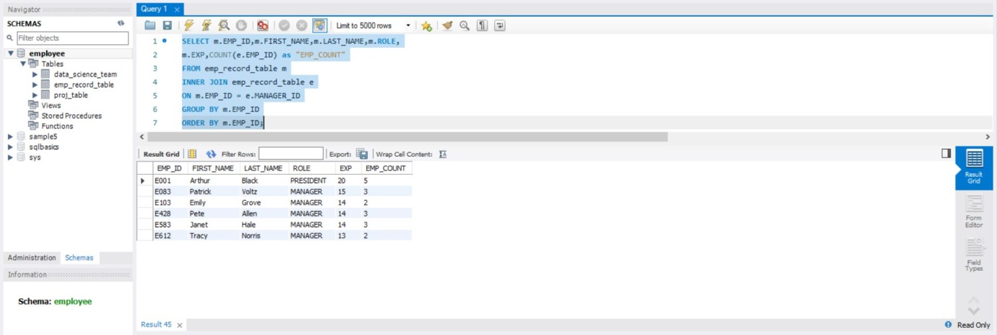

7.Write a query to list down all the employees from the healthcare and finance departments using union. Take data from the employee record table.

SELECT EMP_ID,FIRST_NAME,LAST_NAME,DEPT FROM emp_record_table

WHERE DEPT = "HEALTHCARE"

UNION

SELECT EMP_ID,FIRST_NAME,LAST_NAME,DEPT FROM emp_record_table

WHERE DEPT = "FINANCE"

ORDER BY DEPT,EMP_ID;

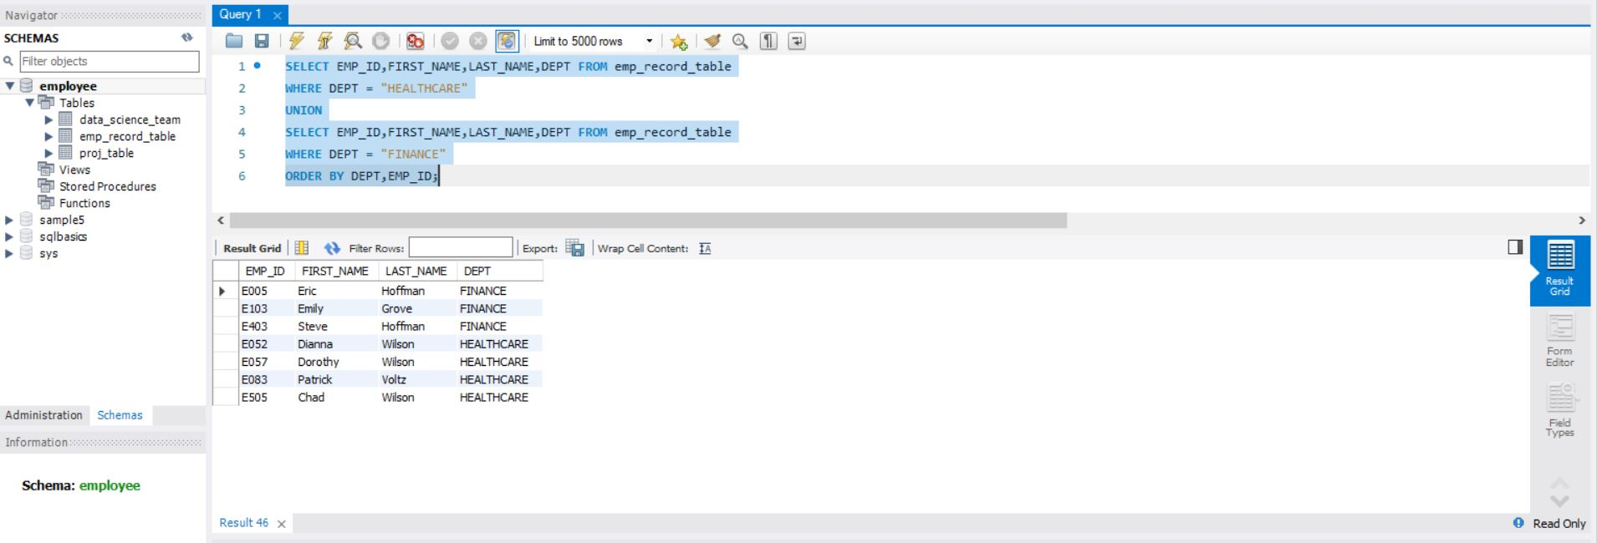

8.Write a query to list down employee details such as EMP_ID, FIRST_NAME, LAST_NAME, ROLE, DEPARTMENT, and EMP_RATING grouped by dept. Also include the respective employee rating along with the max emp rating for the department.

SELECT m.EMP_ID,m.FIRST_NAME,m.LAST_NAME,m.ROLE,m.DEPT,m.EMP_RATING,max(m.EMP_RATING)

OVER(PARTITION BY m.DEPT)

AS "MAX_DEPT_RATING"

FROM emp_record_table m

ORDER BY DEPT;

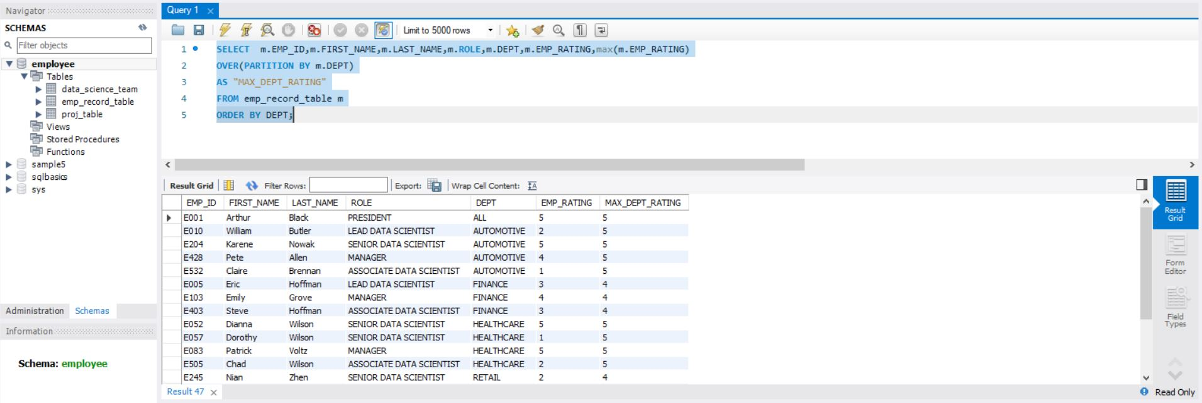

9.Write a query to calculate the minimum and the maximum salary of the employees in each role. Take data from the employee record table.

SELECT EMP_ID, FIRST_NAME, LAST_NAME, ROLE, MAX(SALARY), MIN(SALARY)

FROM emp_record_table

WHERE ROLE IN("PRESIDENT","LEAD DATA SCIENTIST","SENIOR DATA SCIENTIST","MANAGER","ASSOCIATE DATA SCIENTIST","JUNIOR DATA SCIENTIST")

GROUP BY ROLE;

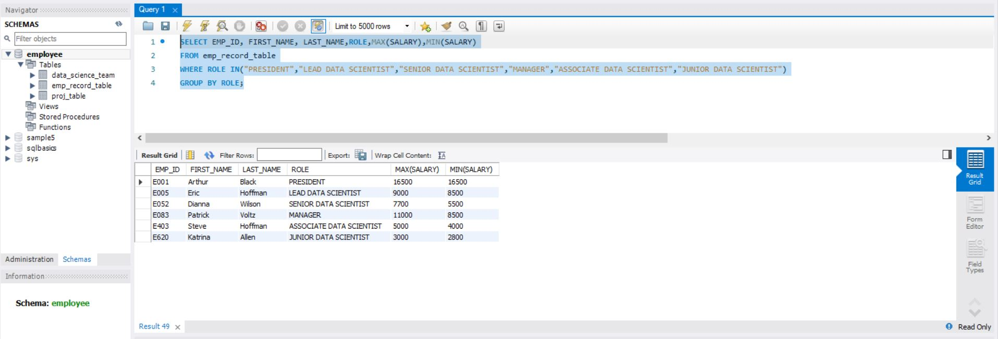

10.Write a query to assign ranks to each employee based on their experience. Take data from the employee record table.

SELECT EMP_ID,FIRST_NAME,LAST_NAME,EXP,

RANK() OVER(ORDER BY EXP) EXP_RANK

FROM emp_record_table;

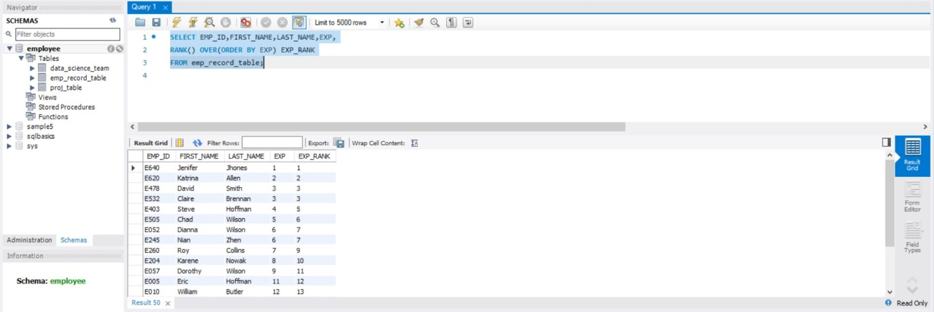

11.Write a query to create a view that displays employees in various countries whose salary is more than six thousand. Take data from the employee record table.

CREATE VIEW employees_in_various_countries AS

SELECT EMP_ID,FIRST_NAME,LAST_NAME,COUNTRY,SALARY

FROM emp_record_table

WHERE SALARY>6000;

SELECT *FROM employees_in_various_countries;

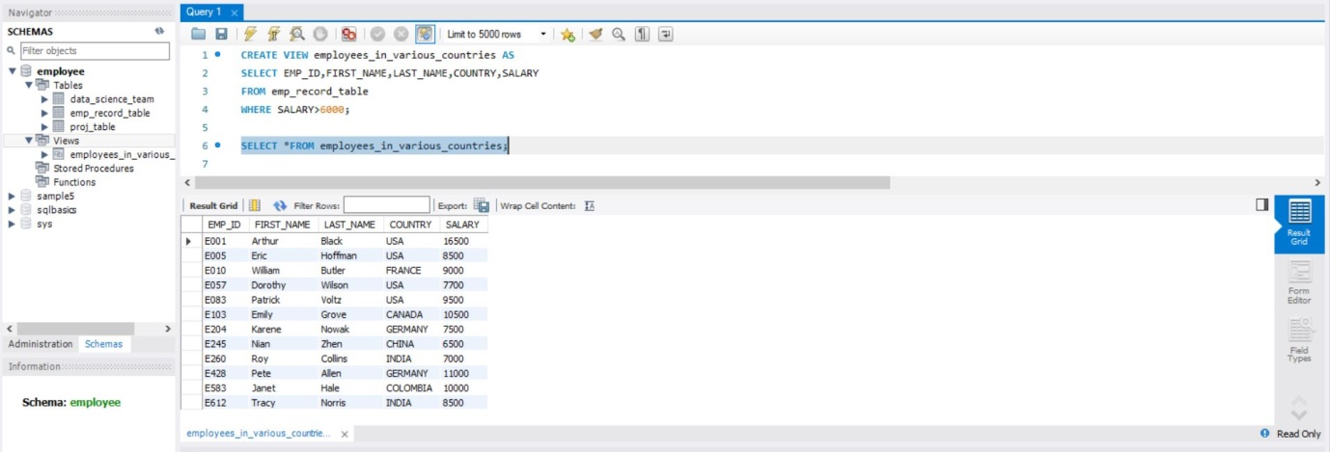

12.Write a nested query to find employees with experience of more than ten years. Take data from the employee record table.

SELECT EMP_ID,FIRST_NAME,LAST_NAME,EXP FROM emp_record_table

WHERE EMP_ID IN(SELECT manager_id FROM emp_record_table);

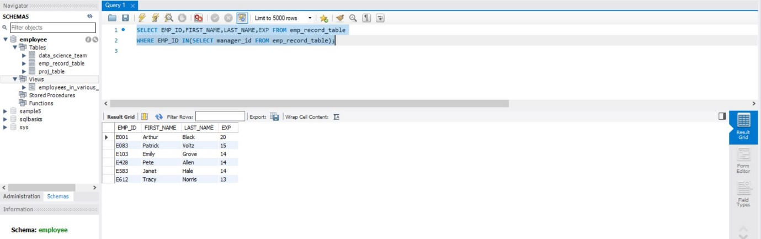

13.Write a query to create a stored procedure to retrieve the details of the employees whose experience is more than three years. Take data from the employee record table.

DELIMITER &&

CREATE PROCEDURE get_experience_details()

BEGIN

SELECT EMP_ID,FIRST_NAME,LAST_NAME,EXP FROM emp_record_table WHERE EXP>3;

END &&

CALL get_experience_details();

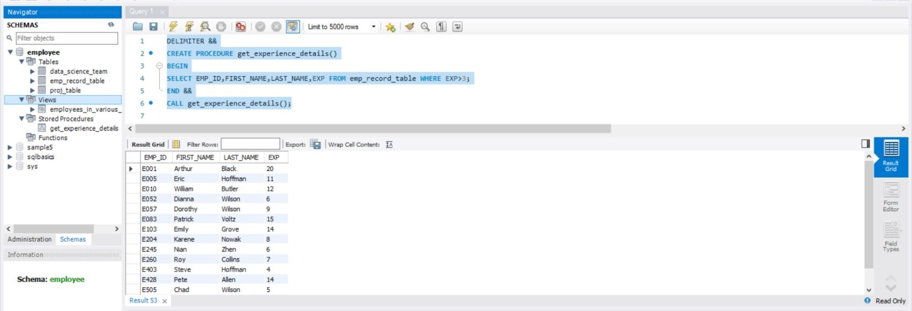

14.Write a query using stored functions in the project table to check whether the job profile assigned to each employee in the data science team matches the organization’s set standard.

DELIMITER &&

CREATE FUNCTION Employee_ROLE(

EXP int

)

RETURNS VARCHAR(40)

DETERMINISTIC

BEGIN

DECLARE Employee_ROLE VARCHAR(40);

IF EXP>12 AND 16 THEN

SET Employee_ROLE="MANAGER";

ELSEIF EXP>10 AND 12 THEN

SET Employee_ROLE ="LEAD DATA SCIENTIST";

ELSEIF EXP>5 AND 10 THEN

SET Employee_ROLE ="SENIOR DATA SCIENTIST";

ELSEIF EXP>2 AND 5 THEN

SET Employee_ROLE ="ASSOCIATE DATA SCIENTIST";

ELSEIF EXP<=2 THEN

SET Employee_ROLE ="JUNIOR DATA SCIENTIST";

END IF;

RETURN (Employee_ROLE);

END &&

SELECT EXP,Employee_ROLE(EXP)

FROM data_science_team;

